Week 1 – The Kingdom of God
Purpose:
Our main purpose is to understand how the coming of the kingdom in Jesus is the starting point and mandate for all Christian discipleship and ministry. Jesus announced and demonstrated the kingdom with authority and then gave his disciples authority and power to do as he did. He commissioned them to announce and demonstrate the kingdom to all the peoples of the earth (as seen in the book of Acts).

Objectives:
- Explain how the Kingdom of God comes in and through Jesus Christ.
- Understand the connection between the rule of God and the authority of Jesus in words and works.
- Connect the era of the kingdom to the era of the Holy Spirit.

Overview:
The central theme of Jesus Christ’s preaching was the Kingdom of God. After all, the kingdom of God is mentioned over 80 times in the New Testament. But what is meant by this phrase? Is the kingdom of God a physical place or a present spiritual reality? Who are the subjects of this kingdom? And does the kingdom of God exist now or only in the future?

Simply put, the kingdom of God can be understood as the complete, whole reign of God. It is the complete saving power of the coming age inbreaking in present reality through the presence of God.

The very complexity of the Biblical teaching about the Kingdom of God is one of the reasons why such diverse interpretations have arisen in the history of theology… The Kingdom is a present reality (Matt 12:28), and yet it is a future blessing (1 Cor 15:50). It is an inner spiritual redemptive blessing (Rom 14:17) which can be experienced only by way of the new birth (John 3:3), and yet it will have to do with the government of the nations of the world (Rev 11:15). The Kingdom is a realm into which men enter now (Matt 21:31), and yet it is a realm into which they will enter tomorrow (Matt 8:11). It is at the same time a gift of God which will be bestowed by God in the future (Luke 12:32) and yet which must be received in the present (Mark 10:15). Obviously, no simple explanation can do justice to such a rich but diverse variety of teaching…

Jesus came announcing that the future age had dawned with his arrival. Yet the way he announced and taught about the kingdom had a sense of mystery. The diagram below illustrates this reality.

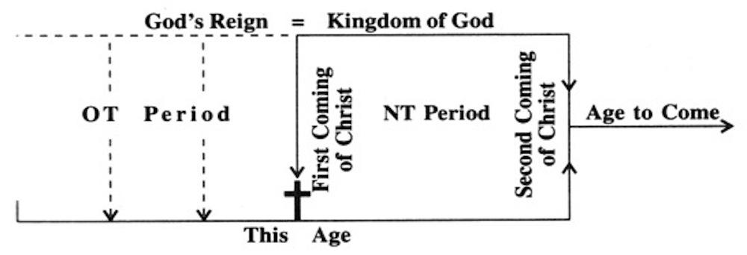

Broken down, Jesus spoke of it as being:
- Near (Matthew 12:28; Luke 10:9; Luke 11:20),
- Present (Matthew 3:2; Luke 17:20-21),
- Delayed (Luke 19:11),
- Future (Matthew 25:31-34)

We describe what Jesus taught and represented as enacted, inaugurated eschatology, or more popularly “the already and the not yet.”

From this definition of the nature of the kingdom, we have developed a set of initial implications:
- The end has come in Jesus; therefore, Jesus is God.
- The last days begin with Jesus and Pentecost, and continue till the very end, so the whole period, from the first to the Second Coming (Parousia), is the last days.
- The veil torn when Jesus died shows that the separation of the present age and age to come has been opened. Therefore, the powers and presence of the future age are continually available. We live in a dimension where it is always near, present, delayed and future.
- Every part or aspect of the kingdom is potentially available every time it breaks through.
- Church history bears witness to the increasing in-breaking of the kingdom as we approach the end of the end. Every revival is a fresh in-breaking of the kingdom.
- This is the framework for understanding world missions.
- This is the framework for understanding the Christian life, in the “already” and “not yet”, making us “already—not yet” people.
- This is the framework for understanding healing, why it occurs, yet does not always occur.
- This is the framework for understanding the witness of the church in the world and the confrontation between human injustice and divine justice, or the social implications of the gospel.
- This is the framework for understanding Christian stewardship of the environment.

Discussion:
- Are you familiar with this understanding of the kingdom of God? How do you see the message and mission of Jesus differently?
- Discuss the diagram with one another.
- Which of the ten implications stand out most to you?
- One of Vineyard Columbus’ focused prayers for 2021 is to “Plant the Kingdom”. How might that come to fruition considering this understanding of the kingdom of God?
- In what ways can we participate in the work of God’s kingdom in our midst? Pray for one another on how we might live into God’s kingdom breaking out in our midst.

Ladd, George Eldon., The Gospel of the Kingdom, 18.

